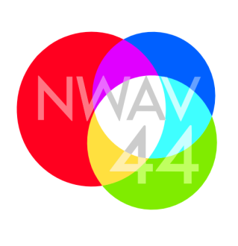

New Ways of Analyzing Variation 44: Intersections
Toronto, October 22-25, 2015
March 27, 2015
Dear Plenarists and Cornerpost speakers,

We are now within eight months of NWAV 44 and would like to give you an update on developments.

We are very happy to report that we will be able to cover your travel costs. At this time, we are still organizing the details, but we should have an update on procedures for you soon. As for accommodation, we will arrange for your stay at the Holiday Inn Bloor Yorkville within a short walking distance of the main venue, Hart House.

We can now provide you with a general schedule for your presentations. The combination of the main NWAV program and simultaneous workshop, Variation at the Crossroads, made scheduling particularly challenging for us and it has taken us some time to sort it all out. We would like to thank you for your input and co-operation.

Thursday | Friday | Saturday | Sunday
 | welcome  J.K. Chambers | morning  Elizabeth Johnson | morning  Shana Poplack
 | morning  Benedikt Szmrecsanyi |  | mid-day  William Labov
evening  David Adger | evening  Susan Pintzuk | evening  Miriam Meyerhoff

If you have not done so already, please send us a final title and abstract for your talk. We would like to post these on the website as soon as possible. You can find it at: http://linguistics.utoronto.ca/nwav44/

We very much look very much forward to your contributions!

The NWAV44 Organizing Committee
Philipp Angermeyer, Michol Hoffman, Naomi Nagy,
Sali A. Tagliamonte, Ann-José Villeneuve, James Walker

