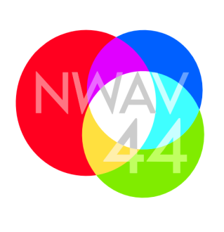
New Ways of Analyzing Variation 44: Intersections
Toronto, October 22-25, 2015

invoice NO.  20150514-01 | DATE OF invoice:  14 May 2015 | PAYMENT DUE DATE :  14 June 2015
Client / donor INFORMATION
Presses de l’Université Laval
Pavillon de l’Est
2180, chemin Sainte-Foy, 1er étage
Québec (Québec) G1V 0A6 Canada
Item |  |  | amount
Total: |  |  | $ 150.00
COMMENTS
Cheques payable to the University of Toronto (indicate “NWAV 44” in the memo) can be mailed to the address below (attn “Sali Tagliamonte, Publishers liaison, NWAV44”).

