Dear Reviewer,
Thank you for agreeing to review for NWAV 47 this year. You will need to accept this invitation through EasyChair to access the abstracts to review.

Reviews are due by June 29th.

Instructions for completing reviews through Easy Chair:
1. Log into EasyChair
Go to h​ttps://www.easychair.org/account/signin.cgi​ and login with your EasyChair account. If you do not have an EasyChair account, follow the link to create one.

2. Access the abstracts to review
Click Conferences in the top left
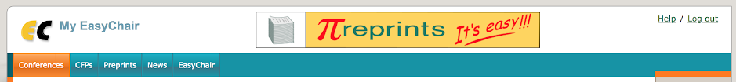

Choose NWAV 47 from the list.
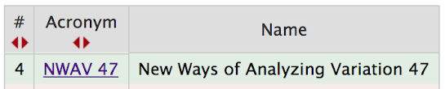
You should see the abstracts that have been assigned to you. Click on the folder icon 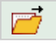to download an abstract as a PDF. Click Download submissions in the upper right corner to download all abstracts as PDFs.

3. Submit your review
When you’re ready to submit a review, first click the blue “i” button next to a paper.
Then click Add review in the upper right corner.
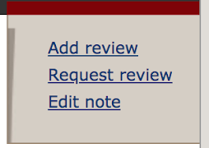

Complete the form, providing an overall evaluation, comments to the author, your confidence in your review, and your assessment of whether the abstract is best suited for a poster, talk, or either. Finally, although we have done our best to avoid this, please let us know if we assign you an abstract by authors with whom you have a conflict of interest (e.g. a student or co-author of yours).

We want to emphasize that the reviewing process is for assessing the quality of the submission and how well it addresses language variation. If you have concerns about the paper's fit for the conference, please let us know in the section entitled ‘Confidential remarks for the program committee.’ However, please do not let that concern affect your rating of the paper's quality.

Best,
NWAV 47 Abstract Committee

