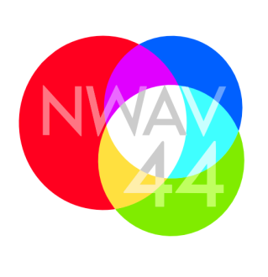
New Ways of Analyzing Variation 44: Intersections
Toronto, October 22-25, 2015
Call for Papers
We are pleased to announce our Call for Papers for New Ways of Analyzing Variation (NWAV) 44 in Toronto: we invite submissions for papers and/or posters in all areas related to language variation. Abstracts should be submitted via the online abstract submission page.
Abstracts should be no more than 500 words, excluding references, and must be anonymized to omit all information about the author(s). If references are cited in addition to the 500-word limit, publications from the author(s) should also be omitted in the reference section. Abstracts and presentations may be in either of Canada's official languages (English or French). All abstracts should be submitted as PDF files.
Authors may submit one singly-authored and one jointly-authored abstract, or two jointly-authored abstracts; the submission limit applies to all NWAV44 sessions, regardless of type (regular, Intersections or thematic). Abstracts will be anonymously reviewed. Abstracts will be considered for both oral and poster presentations. Oral presentations will be selected for four parallel sessions; presenters will have 20 minutes to present and 5 minutes for questions. Poster presentations will be featured at a two-hour plenary poster session on Friday, October 23.
We are also accepting abstracts for contributions to the five Intersections sessions associated with the Variation at the Crossroads workshop. Authors should consult the descriptions of each Intersections invited address on the workshop page and then indicate on the submission page which session, if any, they would like to have their abstract considered for. If the abstract is accepted, the committee will determine whether to incorporate it into a Variation at the Crossroads: Intersections session or assign it to one of the regular NWAV 44 sessions.
We are also accepting abstracts to be considered for three thematic sessions: Short vowels in varieties of English, Linguistic conservatism in heritage and diaspora varieties, and Le français en Ontario. Please indicate on the submission page if you would like to have your abstract considered for one of these.
Abstracts flagged for consideration in either a Intersections Workshop session or a thematic session will undergo regular review.
For further information on the conference, please check the official website, the Facebook page, and the Twitter account regularly.
For general inquiry, including hotel-room sharing and student crash-space, please check the official website for updated information and contacts. Questions about abstract submission should be directed to nwav44@chass.utoronto.ca.
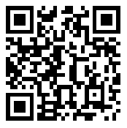
The NWAV44 Organizing Committee
Philipp Angermeyer, Michol Hoffman, Naomi Nagy,
Sali A. Tagliamonte, Anne-José Villeneuve, James Walker
* * * * * * * * * * * * * * * * * * * * * * * * * * * * * * * * * * * * * * * * * * * * * * * *
Calendar
Abstract submissions accepted: May 1 to June 1, 2015
Acceptances/rejections sent: Early July 2015
Program available online: Early August 2015
Early online conference registration: May 15 to August 15, 2015
Regular online conference registration: August 15 to October 1, 2015
On-site registration : October 22, 2015

