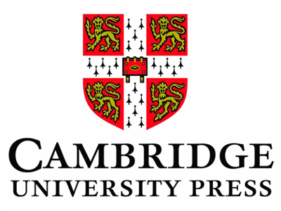

The Cambridge University Press Prize for Best Student Paper at NWAV 2015
is awarded to

Katherine Hilton
Stanford University
_____________________________

The Prize: a choice of Cambridge University Press books to up to the value of $100. Please browse our online books catalogue at www.cambridge.org and email your selection to awinnard@cambridge.org

